Maximum marks for Assignment: _________6______ Assignment Declaration Date:____________
Assignment Submission Date (on or before):______________________________
Assignment assessment declaration Date by faculty (on or before):________________________
Q. NO | Question Statement | Level of mapping and Number |  |  | Blooms Level | Marks
Q. NO | Question Statement | CO | PO | PSO
Q1. | Explain in detail elements of SQA | CO4 | PO1 |  | 1 | 2
Q2 | How cost and risk factors are affecting software quality | CO4 | PO1,PO2 |  | 2 | 4
Q3 | State & explain Principles of Quality management | CO4 | PO1 |  | 1 | 4
Q4 | Explain various activities performed in procedural approach for QM. | CO4 | PO2,PO3 |  | 2 | 6
Q5 | What is CMMI ? | CO4 | PO1 |  | 3 | 4
Q.6 | Differentiate between Quality control, Quality assurance and quality management | CO4 | PO2,PO3 |  | 3 | 4
Q.7 | What does SQA ensure? What are the goals of SQA | CO4 | PO4 |  | 3 | 4
Q.8 | What are the ISO 9000 Quality standard. What are its advantages | CO4 | PO1 |  | 2 | 4
Q.9 | What is SQA? Elements of SQA. List the various objectives of SQA. | CO4 | PO1,PO2 |  | 2 | 6
Q.10 | Explain Six Sigma for software engineering. Explain the terms DMAIC & DMADV | CO4 | PO4,PO5,  PO11 |  | 2 | 6
B. level | Blooms Taxonomy terms
6 | 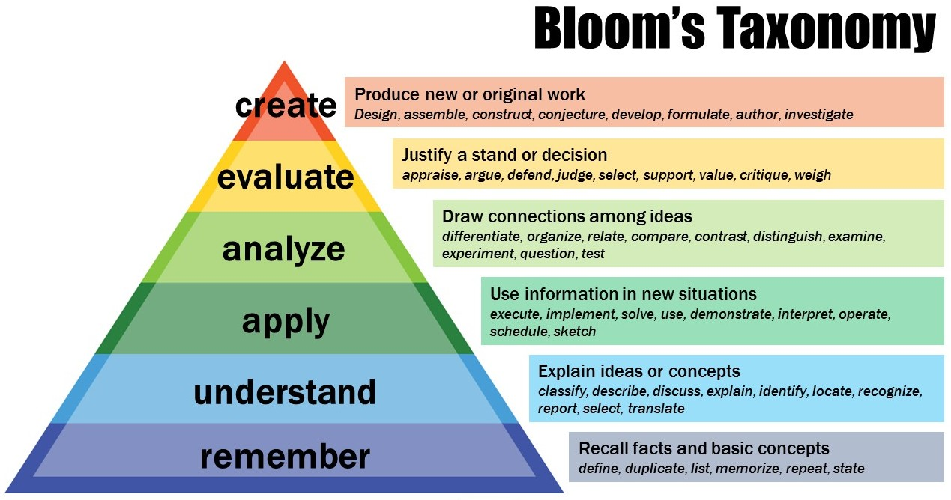
5
4
3
2
1

Subject In-charge HOD

